AALIM MUHAMMED SALEGH POLYTECNIC COLLEGE

“NIZARA EDUCATIONAL CAMPUS”

MUTHAPUDUPET IAF AVADI CHENNAI 600055



**A Project report submitted in partial fulfillment of the requirement for the award of**

**DIPLOMA IN MECHANICAL ENGINEERING**

**“DESIGN AND FABRICATION OF A ROBOTIC ROOM SWEEPER”**

**PROJECT MEMBERS**

1. KHAJA EZZAZUDTHEEN AHAMED .F 18213605
2. JOGESHWARE RA0 18213601
3. KUMAR.M 18213610
4. MARSHAL.S 18213613
5. KARIMULLA RAJA.R 18213602
6. MOHAMMED JAFEER HUSSAIN.T 18213619

GUIDED BY

Mr. DILLI.M.V B.E..,

**BONAFIDE CERTIFICATE**

AALIM MUHAMMED SALEGH POLYTECNIC COLLEGE

“NIZARA EDUCATIONAL CAMPUS”

MUTHAPUDUPET IAF AVADI CHENNAI 600055

DEPARTMENT OF MECHANICAL ENGINEERING

PROJECT WORK

This certify that project entitled “**“DESIGN AND FABRICATIONOF A ROBOTIC ROOM SWEEPER” is the bonafide record of the work done by** KHAJA EZZAZUDTHEEN AHAMED(18213605) of the sixth semester for the year 2017-2020 for the award of diploma in mechanical engineering

**PROJECT GUIDE HEAD OF DEPARTMENT**

**(Mr M.V DILLI B.E..,) (Mr. R.VIGNESH M.E)**

Submitted for sixth semester BOARD EXAMINATION to be held on

**AT AALIM MUHAMME SALGEH POLYTECHNIC COLLEGE AVADI IAF, CHENNAI** **-55**

**INTERNAL EXAMINAR EXTERNAL EXAMINAR**

**ACKNOWLEDGMENT**

**ACKNOWLEDGMENT**

We owe our gratitude to **Almighty** for the inspiration and guidance in all the stages of the execution of the project work

We are thankful to our founder late **Dr. S.M SHAIKH NURDDIN** honourable

Correspondent **JANAB S.SEGU JAMLUDEEN ,** managing trustee **JANAB SHAIKH**

**ATHULLHA** for providing a good infrastructure and laboratory facilities to work

For the project.

I am very thankful to **Mr. KHADEER AHAMED, M. Tech , PRINCIPAL AALIM**

**MUHAMMED SALEGH POLYTECHNIC COLLEGE,** for his interest towards this project.

I express my sincere to **Mr. R.VIGNESH M.E.., HEAD OF THE DEPARTMENT OF**

**MECHANICAL ENGINEERING,** for having given spontaneous and whole hearted encouragement for completing this project.

I deemed it a pleasure and privilege to feel indebted my project coordinator

**Mr. M.M JAINUDEEN B.E., DEPARTMENT OF MECHANICAL ENGINEERING,**

Whose guidance has proved indispensable to the successful completion of my project.

Our special thanks to project guide **Mr. M.V.DILLI B.E.,,** of mechanical engineering for given a technical ideas for our successful project.

On pleasure note I would like to utilize opportunity to extend my nearest and respectable thanks to all **Teaching and non-teaching staff of the DEPARTMENT OF MECHANICAL EGINEERING AALIM MUHAMMED SALEGH POLYTECHNIC COLLEGE** , for their commendable support and encouragement for this project.

**CONTENTS**

**Chapter No Title Page No**

**Abstract**

**1 Introduction**

**2 Project Survey**

**3 Description of components**

**4 Line Diagram**

**5 working**

**6 advantages and Disadvantages**

**7 Required Material**

**8 Conclusion**

**ABSTRACT**

The vacuum cleaner is an apparatus that creates a partial vacuum and is used to suck up dust and dirt. It uses an air pump to create a vacuum and clean floor, but it can also clean other surfaces. what a vacuum cleaner sucks into itself is collected into a dust bag or a cyclone and later disposed and tank has water the water will goes to ground by gravitational force and the tube has 12 v solenoid valve the mop has roller design and it will be attached in back side of the robot and the working is first step is vacuum cleaner and droplets for tank last step is mop it will clean the floor

**INTRODUCTION:**

The robot fabrication by sheet metal and square steel pipe. The robot has vacuum cleaner module and water droplets from tank and the mop is attached in back side of robot. The purpose of robot is clean the floor in three steps are

* Vacuum cleaner
* Water droplets
* Mopping

The robot looks like a model of car and working like vacuum cleaner, using mop and water droplets to clean the floor. the futures of a robot is three in one the processes are vacuum cleaning, putting water droplets and mop .The robot controlled with Bluetooth device by using android system. the robot has four wheels the first two wheel is 360 degree wheels and another two wheels are connected with 12v dc motor. The suction power is created by 12v suction fan the robot runs with a power of 12v 7.2ah battery. the robot has battery charger also the battery charging time is 8 hours

**PROJECTSURVEY:**

* Fabrication material cost is :1250
* Battery and charger cost is :1050
* Two 12v DC motor cost is :400
* Suction fan cost is :350
* Bluetooth device cost is :800
* 360 wheel cost is :400
* Solenoid valve cost is :400
* Normal wheel cost is :200
* Tubes cost is :50

**COMPONENTS:**

* Square steel pipe
* Sheet metal
* Two 12v DC motor
* Bluetooth module HC-06
* Motor driver circuit
* Arduino board
* 360 wheel
* Normal wheel
* Solenoid valve
* Suction fan
* Battery
* Charger
* Tubes
* Mop

**DESCRIPTION OF COMPONENTS**

**SQUARE STEEL PIPE :**

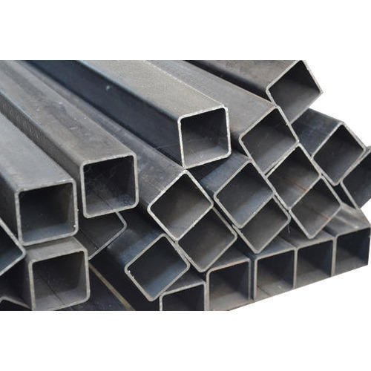

* The steel pipe dimensions is 15*15mm.
* The pipe is used to frame work and to design the car model.

**SHEET METAL:**

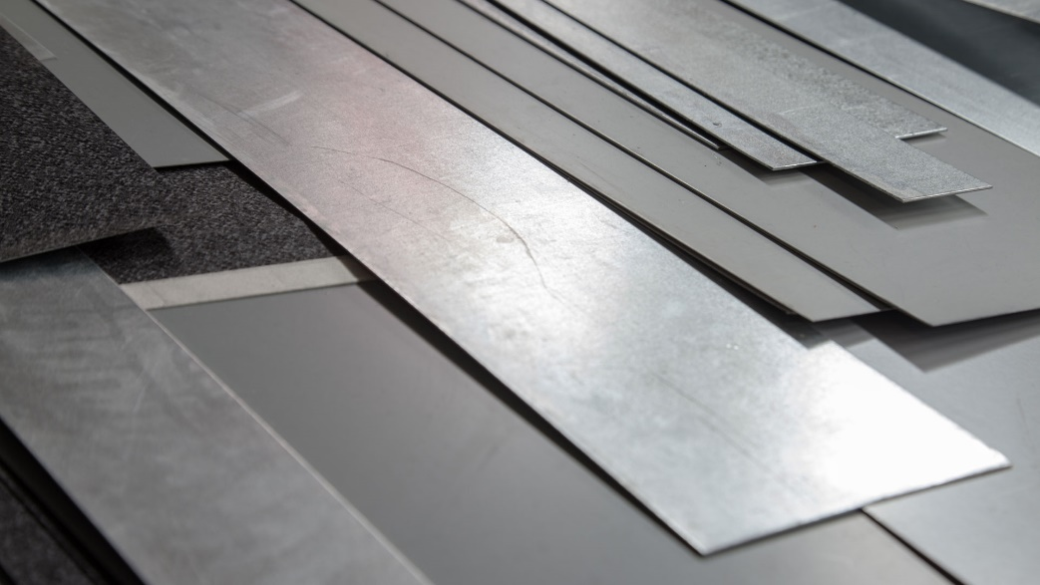

* The sheet metal is used for fabrication work.

**TWO 12V DC MOTOR:**

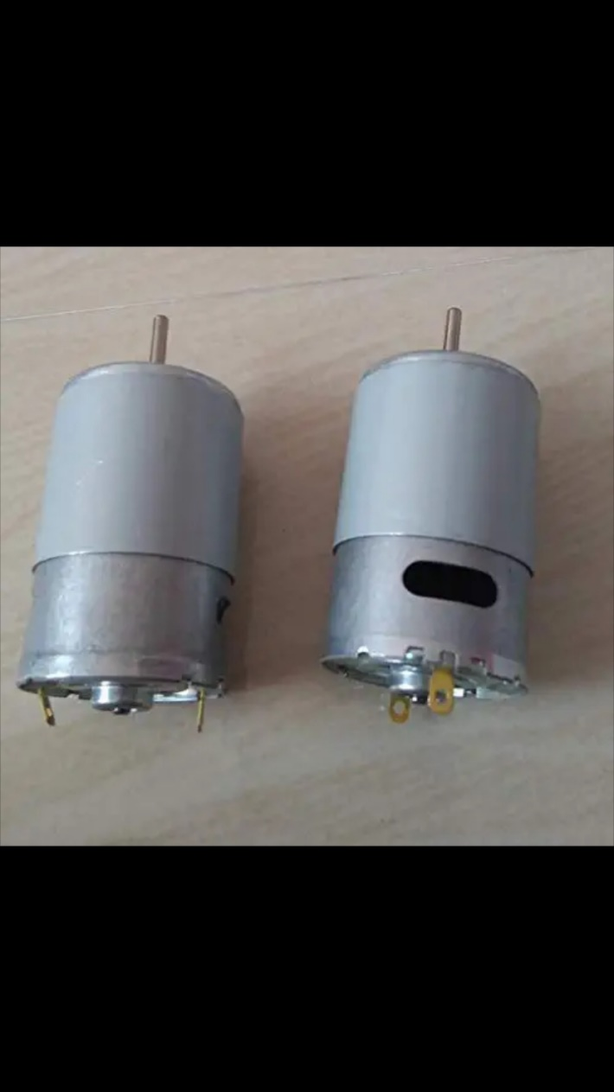

* A DC motor is any motor within a class of electrical machines whereby direct current electrical power is converted into mechanical power.
* A 12v DC motor is small and in expensive, yet powerful enough to be used for many application.

**SUCTION FAN :**

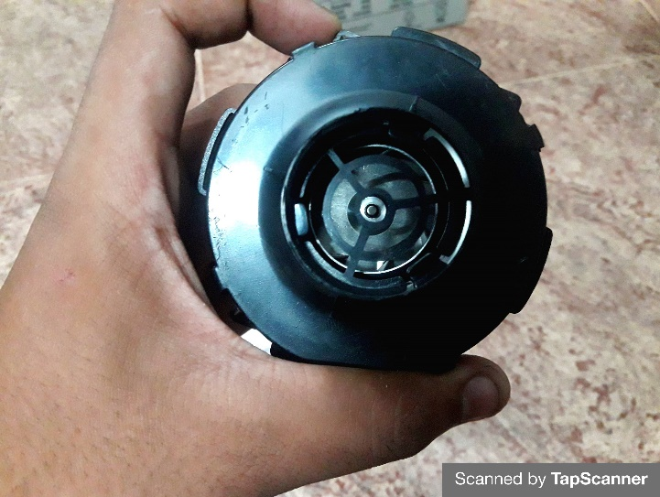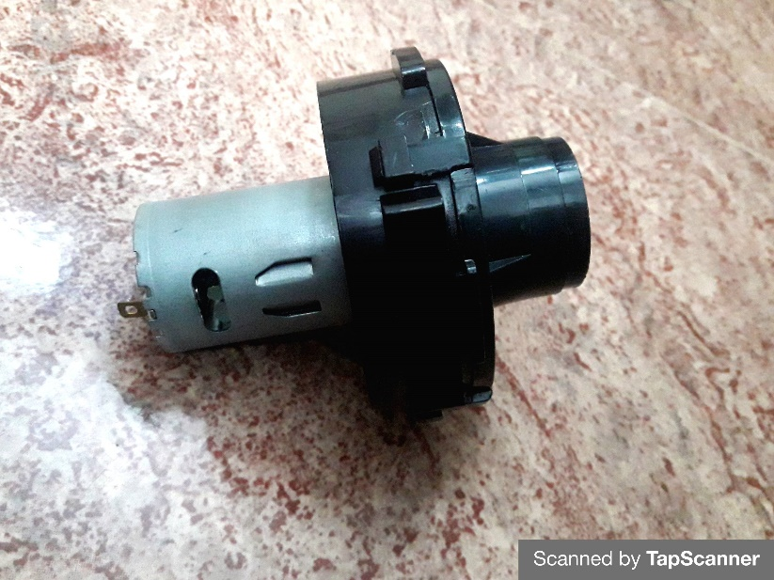

* Definition of suction fan. A fan that sucks or draws the air toward it through airways or air pipes.
* The term generally used is exhaust fan.

**BLUETOOH MODULE:**

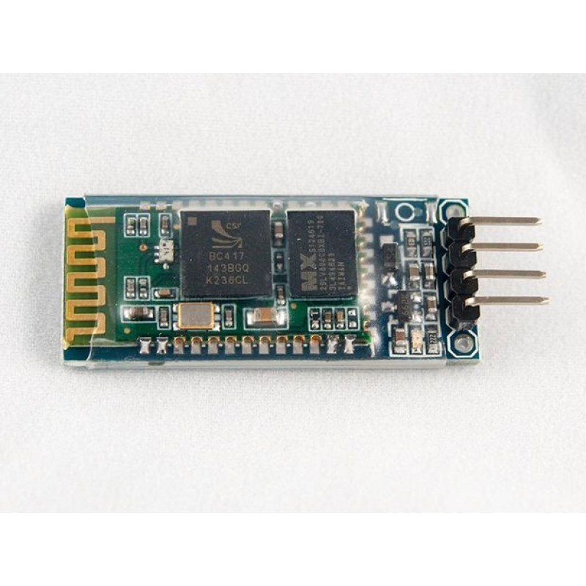

* HM-06 is a Bluetooth module designed for establishing short range wireless data communication between two microcontroller or systems.
* The module work on Bluetooth 2.0 communication protocol and it can only act as a slave device.

**ARDUINO DEVICE:**

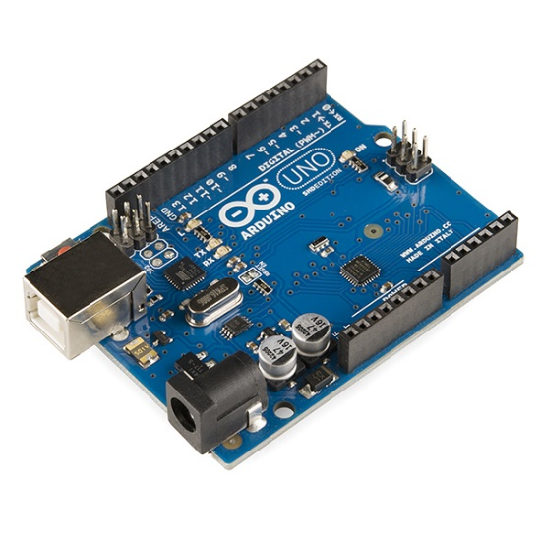

* Bluetooth overview. The android platform includes support for the Bluetooth network stack, which allows a device to wirelessly exchange data with other Bluetooth device.
* There APLs let application wirelessly connect to other Bluetooth device, enabling point-to- point and multipoint Wireless features.

**360 DEGREE WHEEL:**

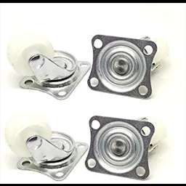

* AS a result vehicle is move in backward direction. steering is part of 360 degree wheel rotation vehicle .
* This part is used to provide the direction to the front wheel by help sprocket and chain drive, which provides direction to the front wheel clockwise direction.

**12V DC SOLINOID VALVE:**

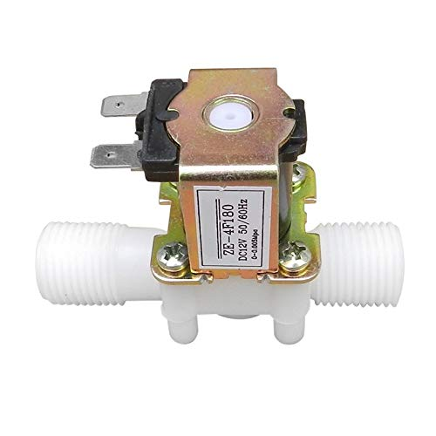

* Description 12 v dc ½” electric solenoid water air valve switch (normally closed) controls the flow of fluid+ air and act as a valve between high- pressure water or any fluid… as it is opens the flow of liquid as soon as power on and stop/ block the flow when the supply voltage removed.

**NORMAL WHEELS:**

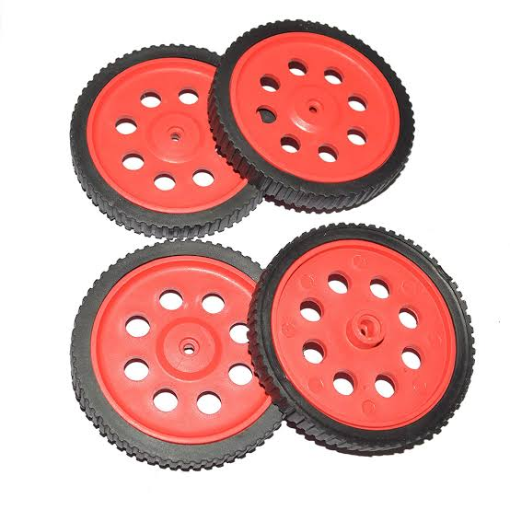

* The wheel size is the size designation of a wheel given by its diameter, width, and offset. The diameter of the wheel is given by measuring the distance from one side of the wheel to the other, through the center point of the wheel . The width is the distance measured from the seat to other bead seat.

**PLASTIC PIPE:**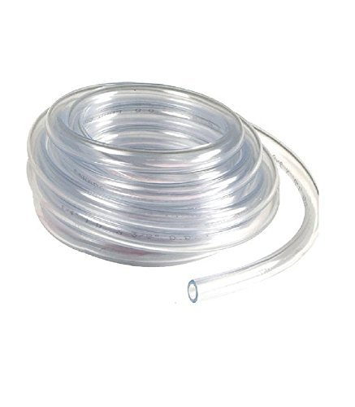

* Plastic pipe is a tubular section, or hollow cylinder, made of plastic. It is usually, but not necessarily, of circular cross-section, used mainly to convey substances which can flow-liquids and gases (fluids), slurries, powders and masses of small solids

**LINE DIAGARAM:**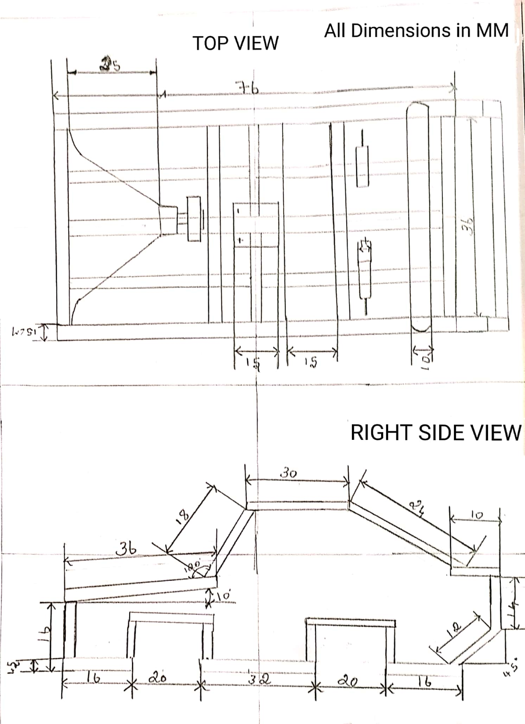

**WORKING:**

* Works starts with a Bluetooth device or android. The Bluetooth pass a signal to HC-06 Bluetooth module. the Bluetooth module is control the motor drive, suction fan, solenoid valve the first step is connected the Bluetooth device and Bluetooth module and Bluetooth device pass a signal to Bluetooth module.
* The Bluetooth module switch is on the dc motor to move a robotic room sweeper in starting place and the suction fan, water droplets and mop motor also on.
* The dc 12 v motor will help to move the project on the floor. the second step switch is on solenoid valve and the water tank is fixed on the top of the project and tank has water. The water came to ground by the force of gravity and the water is putted on the ground.
* It is third step and the mop is connected with a 12v DC motor it have cloth it will swiping the floor and absorbed the water on the floor and clean the floor and it is the working of the robotic room.

**CONNECTIONS :**

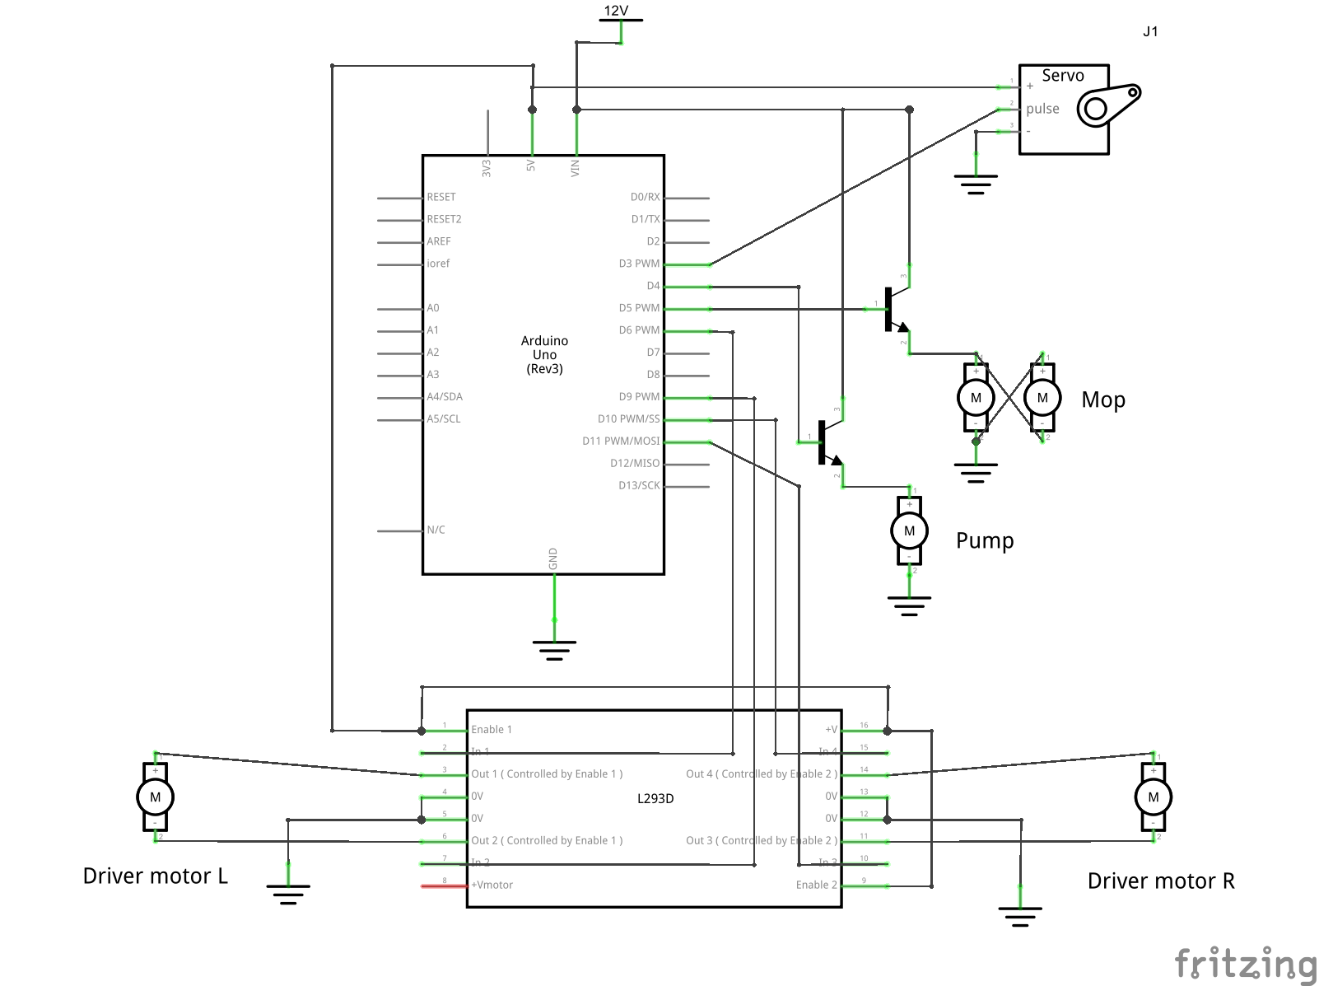

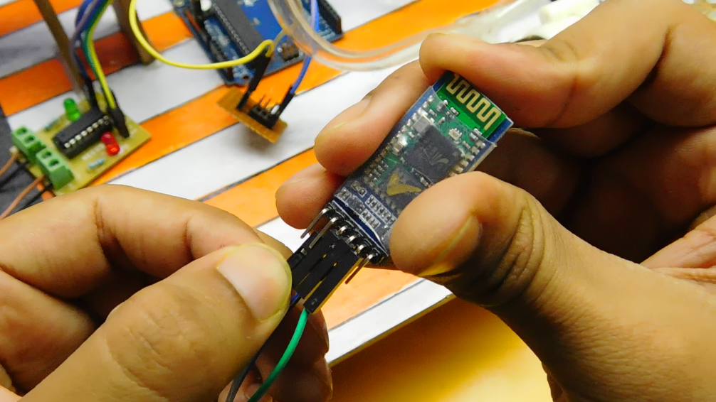

* Now this is always the typical part. You have to be accurate. For making it a bit easier, I always use jumper wires which can be swapped or removed any time.
* Before that, drill some holes and fix your arduino in place using some screws.
* Start by connecting the geared motors to the driver board. Solder some wire to the motor terminals and then connect them to the screw terminals of the driver circuit. The rest of the pins have to be connecting as per the following:
* Signal 1 ---- D6 on Arduino
* Signal 2 ---- D9 on Arduino
* Signal 3 ---- D10 on Arduino
* Signal 4 ---- D11 on Arduino
* +5V ---- +5V on Arduino
* Gnd ---- Gnd on Arduino
* +12V (motors will move at this voltage) ---- to be connected to battery later
* Next comes the bluetooth module. Connections are:
* Vcc ---- +5V on Arduino
* Gnd ---- Gnd on Arduino
* Rx ---- Tx on Arduino
* Tx ---- Rx on Arduino
* Add a voltage divider to signal pins if you're afraid that the signal pins on arduino might burn.
* The two mop motors have to be connected in parallel such that the left one runs anticlockwise and the right one turns clockwise when seen from the front. Use heat shrink tubes to keep the connections safe. Solder the motor wires to the transistor circuit as per the schematic given above. Similarly connect the water pump wires as well.
* We will be supplying the 12V from the battery directly to the transistor circuit and then this 12V will go to the Vcc of arduino and the motor driver circuit.
* Connect the base of transistor two, controlling the mops to D5 on arduino and transistor one, controlling the pump to D4 on arduino. The common ground wire from all the motors has to be connected to the Gnd on arduino.
* What remains now is the servo motor. The connections are:
* Vcc ---- +5V on Arduino
* Gnd ---- Gnd on Arduino
* Signal ---- D3 on Arduino
* You can always have a look at the schematic.

**UPLOAD THE CODE :**

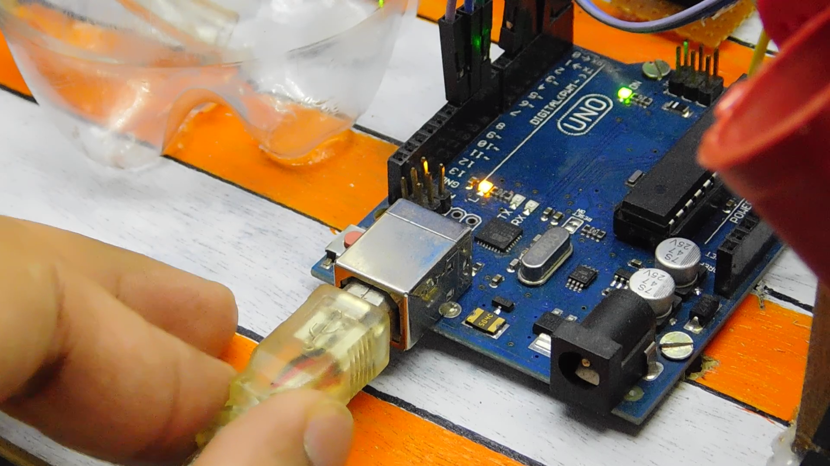

* **Remove the Rx and Tx cables from arduino before uploading!**
* Connect the board to a pc and program it with the code given below. You can make necessary changes.
* Make sure you set the correct COM port and Board under Tools.
* After it's done, replace the Rx and Tx wires. You'll need to remove them everytime you upload the code.

<p>#include <br>Servo myServo;</p><p>int r_motor_n = 10; //PWM control Right Motor +

int r_motor_p = 11; //PWM control Right Motor -

int l_motor_p = 9; //PWM control Left Motor -

int l_motor_n = 6; //PWM control Left Motor +

int pump = 4;

int mop = 5;

int serv = 3;

int speedy = 255;

int incomingByte = 0; // for incoming serial data</p><p>void setup()

{

myServo.attach(3);

myServo.write(0);

pinMode(r_motor_n, OUTPUT); //Set control pins to be outputs

pinMode(r_motor_p, OUTPUT);

pinMode(l_motor_p, OUTPUT);

pinMode(l_motor_n, OUTPUT);

pinMode(pump, OUTPUT);

pinMode(mop, OUTPUT);

digitalWrite(r_motor_n, LOW); //set both motors off for start-up

digitalWrite(r_motor_p, LOW);

digitalWrite(l_motor_p, LOW);

digitalWrite(l_motor_n, LOW);

digitalWrite(pump, LOW);

digitalWrite(mop, LOW);

Serial.begin(9600);

}</p><p>void loop()

{</p><p>if (Serial.available() > 0)

{

incomingByte = Serial.read();

}</p><p>switch(incomingByte)

{</p><p>case 'S': // control to stop the robot

digitalWrite(r_motor_n, LOW);

digitalWrite(r_motor_p, LOW);

digitalWrite(l_motor_p, LOW);

digitalWrite(l_motor_n, LOW);

Serial.println("Stop");

incomingByte='*';

break;</p><p>case 'R': //control for right

analogWrite(r_motor_n, speedy);

digitalWrite(r_motor_p, LOW);

analogWrite(l_motor_p, speedy);

digitalWrite(l_motor_n, LOW);

Serial.println("right");

incomingByte='*';

break;</p><p>case 'L': //control for left

analogWrite(r_motor_n, LOW);

digitalWrite(r_motor_p, speedy);

analogWrite(l_motor_p, LOW);

digitalWrite(l_motor_n, speedy);

Serial.println("right");

incomingByte='*';

break;</p><p>case 'F': //control for forward

analogWrite(r_motor_n, speedy);

digitalWrite(r_motor_p, LOW);

analogWrite(l_motor_p, LOW);

digitalWrite(l_motor_n, speedy);

Serial.println("right");

incomingByte='*';

break;</p><p>case 'B': //control for backward

analogWrite(r_motor_n, LOW);

digitalWrite(r_motor_p, speedy);

analogWrite(l_motor_p, speedy);

digitalWrite(l_motor_n, LOW);

Serial.println("right");

incomingByte='*';

break;</p><p>case 'P': // pump on

digitalWrite(pump, HIGH);

Serial.println("pump on");

incomingByte='*';

break;</p><p>case 'p': // pump off

digitalWrite(pump, LOW);

Serial.println("pump off");

incomingByte='*';

break;</p><p>case 'M':

digitalWrite(mop, HIGH); // mopper on

Serial.println("mopper on");

incomingByte='*';

break;</p><p>case 'm':

digitalWrite(mop, LOW); // mopper off

Serial.println("mopper off");

incomingByte='*';

break;</p><p>case 'U': // roller up

myServo.write(0);

Serial.println("roller up");

incomingByte='*';

break;</p><p>case 'u': // roller down

myServo.write(135);

Serial.println("roller down");

incomingByte='*';

break;</p><p>case '1':

speedy = 155;

Serial.println("speed= 10");

incomingByte='*';

break;</p><p>case '2':

speedy = 185;

Serial.println("speed= 25");

incomingByte='*';

break;</p><p>case '3':

speedy = 215;

Serial.println("speed= 75");

incomingByte='*';

break;</p><p>case '4':

speedy = 255;

Serial.println("speed= 100");

incomingByte='*';

break;</p><p>delay(5000);

}

}</p>

**CONFIGURE THE APP AND CONNECT :**

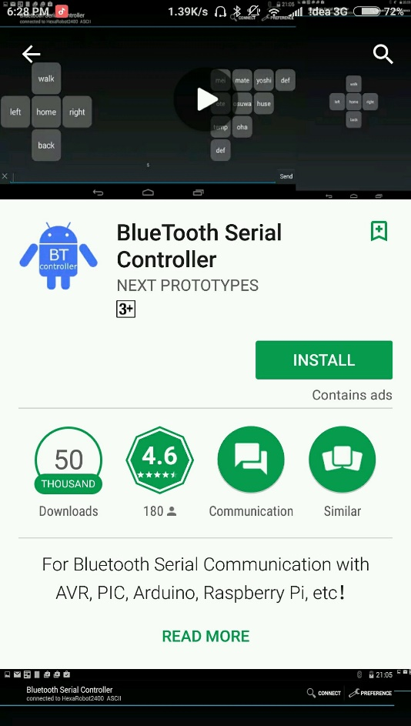

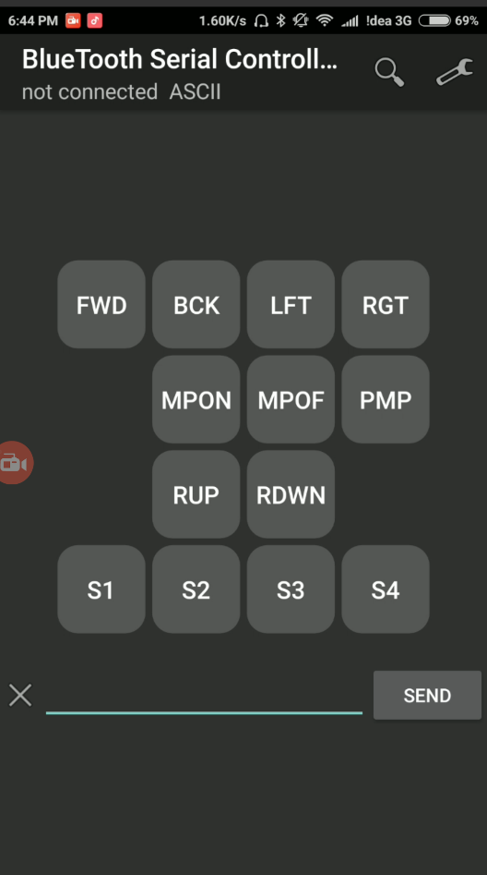

* App called 'Bluetooth Serial Controller' which lets you set your own control buttons and commands.
* After opening the app, click on 'settings' and then 'visibility'
* Turn off visibility for buttons 5, 9, 12 as we won't be needing them.
* Next, go on the 'names' icon so set the display names for each button. Make them short, 3-4 letters.
* Now under the 'commands' option, set the following commands (without quotes) for each button (they are case sensitive):
* Button 1 (FWD): 'F'
* Button 2 (BCK): 'B'
* Button 3 (LFT): 'L'
* Button 4 (RGT): 'R'
* Button 6 (MPON): 'M'
* Button 7 (MPOF): 'm'
* Button 8 (PMP): 'P'
* Button 10 (RUP): 'U'
* Button 11 (RDWN): 'u'
* Button 13 (S1): '1'
* Button 14 (S2): '2'
* Button 15 (S3): '3'
* Button 16 (S4): '4'
* Under the 'stop commands' section in 'commands' itself, you need to set the following stop commands ONLY for the buttons mentioned below:
* Button 1: 'S'
* Button 2: 'S'
* Button 3: 'S'
* Button 4: 'S'
* Button 8: 'p'
* This means that example if button 2 isn't pressed, the command 'S' will be sent which will stop the robot.
* To connect the robot, first pair up the bluetooth module named 'HC-05' or other. Password will be '0000' or '1234'
* Then connect the paired up module via the app.

**ADVANTAGES AND DISADVANTAGES:**

**ADVANTAGES:**

* Required time is less.
* Low cost.
* Operate in any android system.
* It is very effective.

**DISADVANTAGES:**

* The size of a project is more than normal size.
* The robot weight above 10 kgs
* Its not used in small house.
* The warranty is cannot be give.

**CONCLUSION:**

* Works starts with a Bluetooth device or android.
* Bluetooth module is control the motor drive, suction fan, solenoid valve.
* A 12v DC motor and cloth it will swiping the floor and absorbed the water on the floor and clean the floor and it is the working of the robotic room.
* The water came to ground by the force of gravity and the water is putted on the ground.
* The robotic room sweeper is works successfully.